LET’S TALK ABOUT YOUR IDEA!
To become one of six teams to participate in our STARTUP:conversation please fill in the following form and send it to frg@greg.bayern until the 3rd of October. You are free to send the required BACKGROUND info in whatever form you like – use this form or attach documents in your email.

DATA
startup
company name | your info
date of foundation | your info
street | your info
city | your info
pitch deck / presentation  attached (required) | ☐
company logo  attached | ☐
contact person
email | your info
tel | your info

BACKGROUND
status: tell us about your MVP, prototype and / or clients
attached | ☐
optional: fill in your info here
international: do you have any existing connections to bavarian / czech partners?
attached | ☐
optional: fill in your info here
motivation: why do you want tob e part of STARTUP:conversation?
attached | ☐
optional: fill in your info here

Thank you for your curiosity!

STARTUP:conversation is hosted by
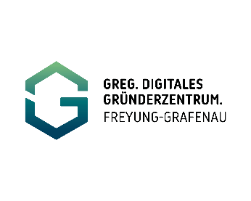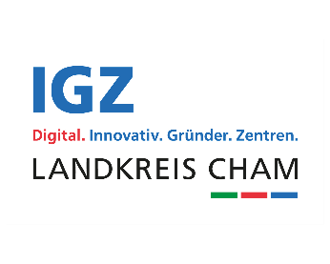

STARTUP:conversation is supported by
Disclaimer:
By sending your application documents you consent to the data provided being electronically recorded and processed by GreG Freyung-Grafenau e.V., IGZ Landkreis Cham and Europaregion Donau-Moldau. Furthermore you consent to your company name and logo being published on the hosts‘ websites, social media channels as well as print media, as well as the transmission of further information by email. If photographs or screenshots displaying the participants are taken in the course of the workshops, the person depicted gives his / her express consent to the exclusive and limited authorization of use with regard to publication, duplication and dissemination of these. These consents can be revoked in writing at any time.

